Book store
Software Requirement Specification

– HCM, July 2023 –
Table of Contents
I. Overview 3
1. Introduction 3
2. System Functions 4
a. Screen Flow…………………………………………………………………………………………………………………………..4
b. Screen Details……………………………………………………………………………………………………………………….5
II. Functional Requirements 5
1. <<Login>> 5
2. <<Register>> 6
3. <<Show homepage>> 6
4. <<Search Book by name>> 7
5. <<Show list of books>> 7
6. <<Show the quantity and product user want order>> 7
7. <<Confirm Order >> 8
8. <<Notice of successful order>> 8
9. <<Noittice of successful order>> 9

I. Overview

1. Introduction
My project is about the book trading website. Web includes user login functions to buy products and update product prices, remove products when not in use.
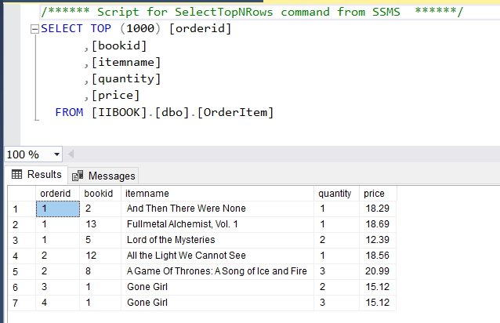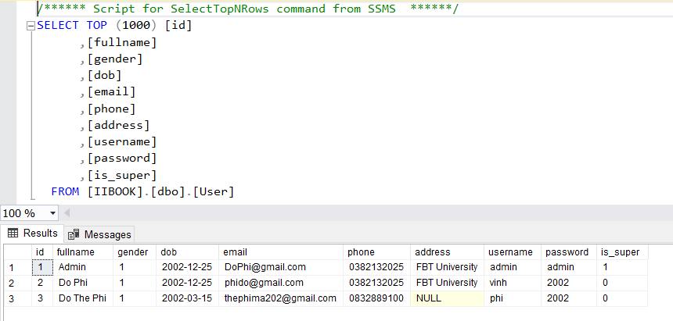
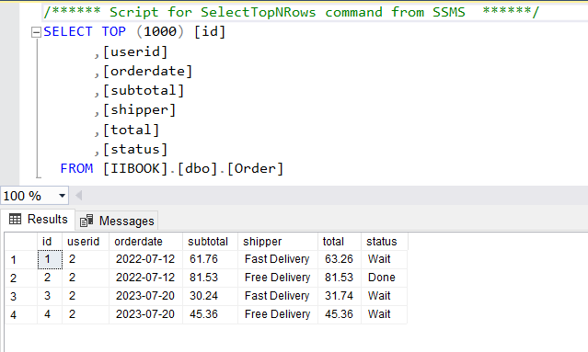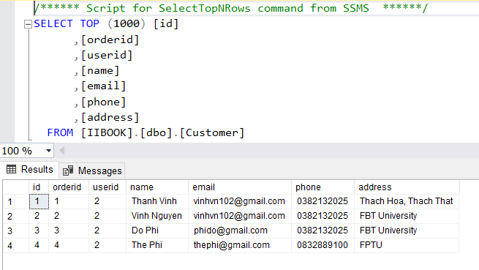
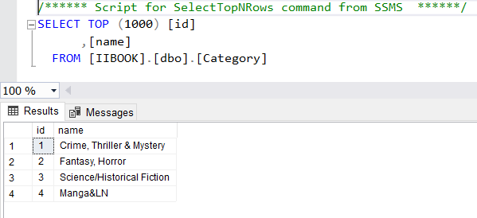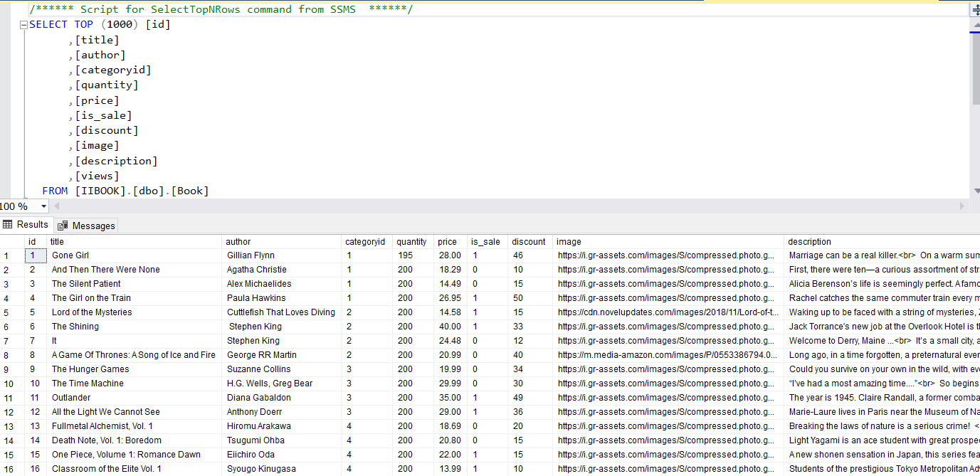
>>

2. System Functions

a. Screen Flow

[This part shows the system screens and the relationship among screens. You can draw the Screens Flow for the system in the form of diagram as below]
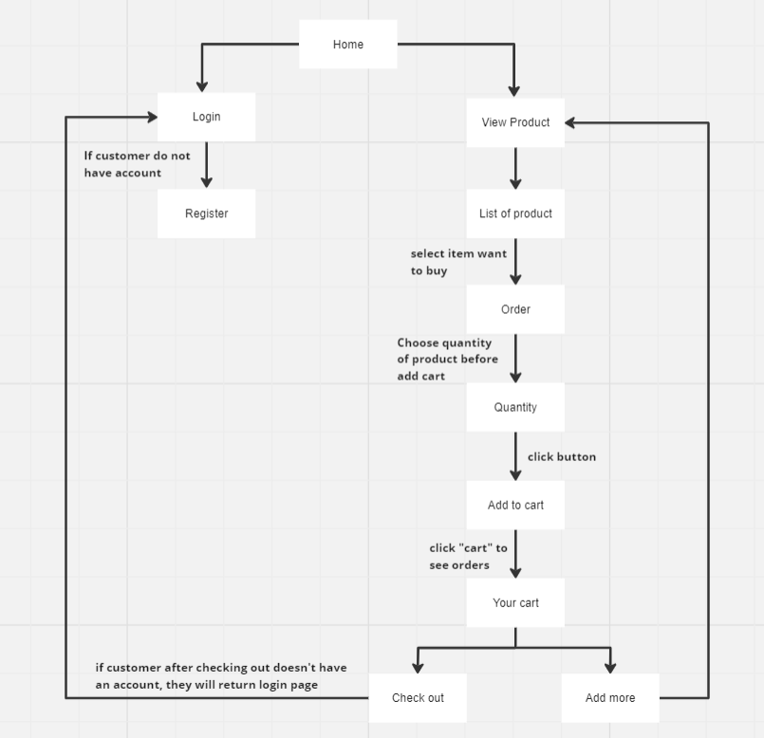

b. Screen Details
[Provide the descriptions for the screens in the Screens Flow above]
b.1 User Wed Application
# | Feature | Screen | Description
1 | View Landing Page about | Landing Page | Contains an introduction about Homepage and the main features of the application.
2 | Get list of book | Home Page | List of book
4 | Get book detail | View Cart | Contains book details about book information, quantities textbox, add to cart button
5 | Login account | Login page | Contains text box to input username and password, login button, register link, login with Gmail button, rem
6 | Register account | Register page | Contains text box to input user information, register button
7 | Check out | Check out page | Click button check out
9 | Buy book | Confirm book | Contains user’s information, quantities , price, check out button.
- …

II. Functional Requirements

1. Login
- Function trigger: after clicking login button or checkout to order book without logging in
- Function description: The system allows users to use their username and password to log in to the system as customer
- Screen layout:
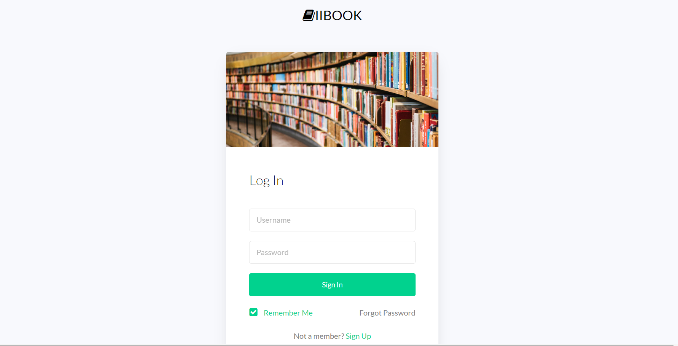

2. Register
- Function trigger: after clicking “Sign up” in “Log in” display
- Function description: The system allows users to register for an account
- Screen layout:
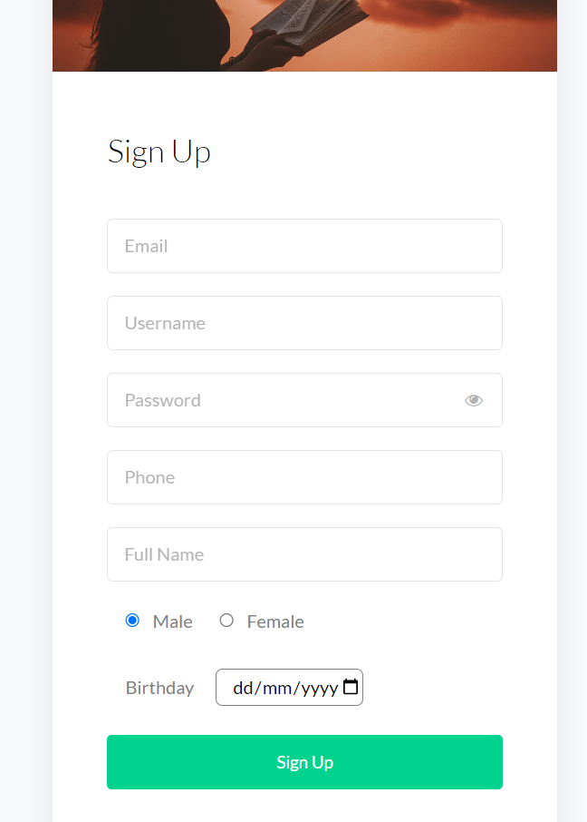

3. Show homepage
- Function trigger: after the clicking “Home” tab
- Function description: the system shows the homepage for user
- Screen layout:



4. Search Book by name
- Function trigger: after choose Name of book clicking search button
- Function description: Display books according to user’s search request
- Screen Layout:

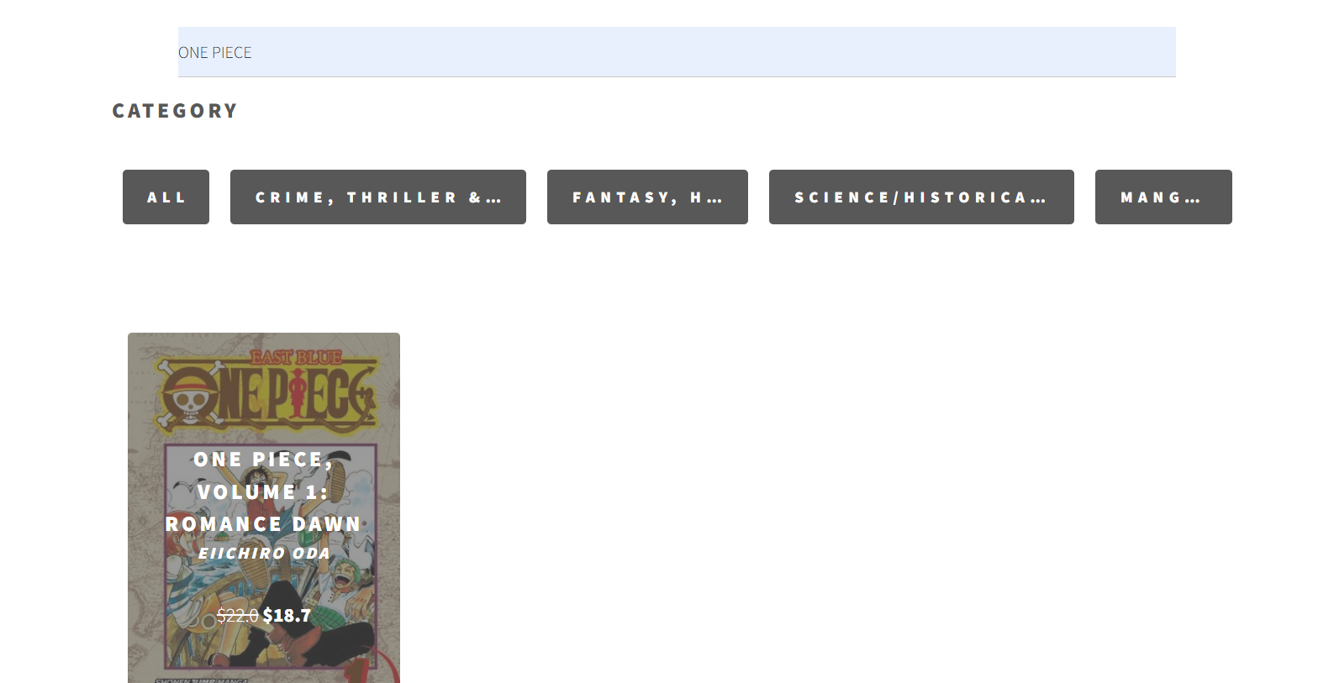

5. Show list of books
- Function trigger: at home page click “bookshelf”
- Function description: after clicking “bookshelf”, system will bring actor to list of many books
- Screen layout:


6. Show the quantity and product user want order
- Screen layout:
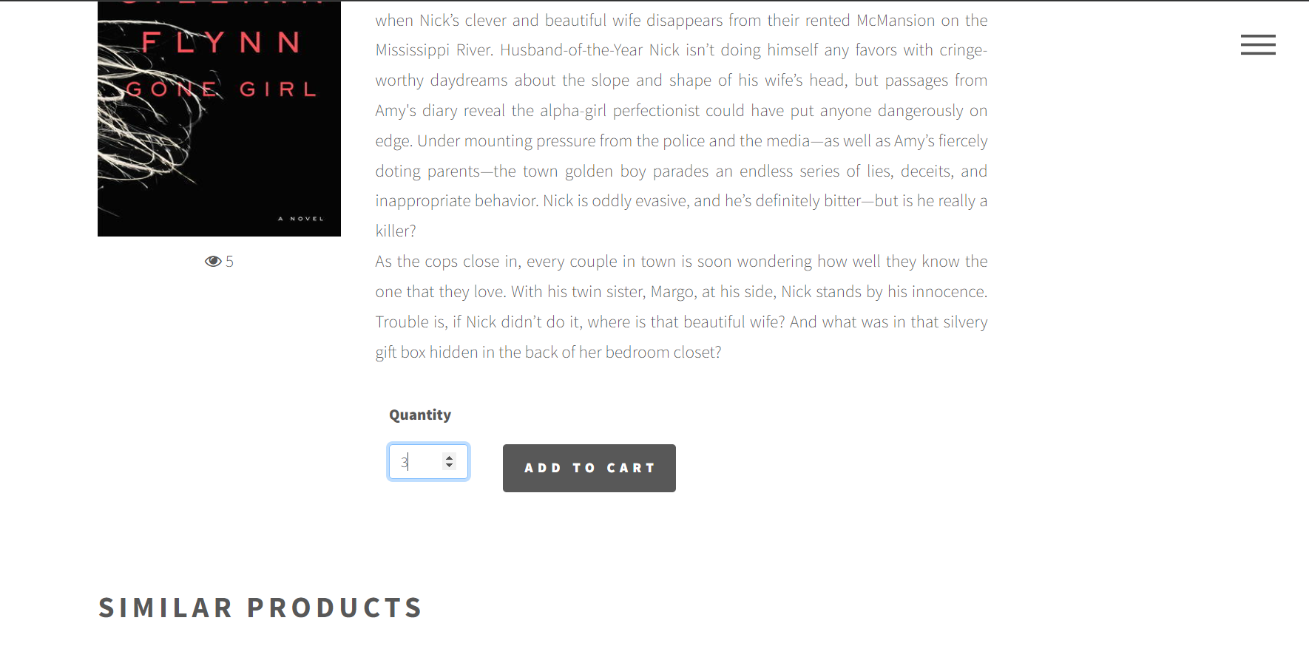

7. Confirm Order
- Function trigger: after choosing item slot of book, then product will add to “cart”
- Function description: display product’s information, quantity, price
- Screen layout: 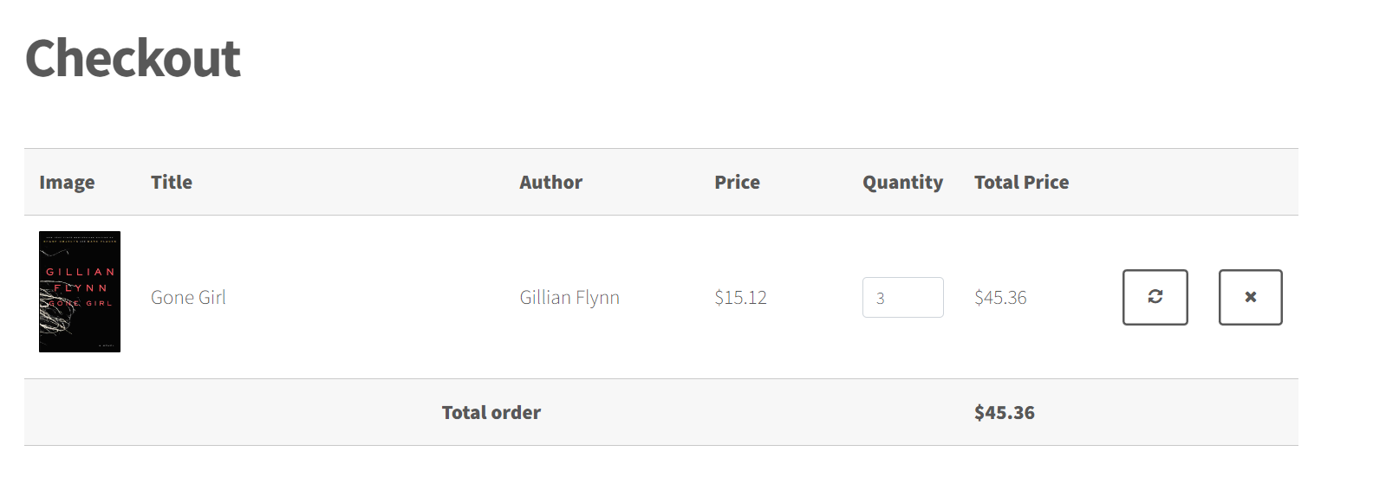

8. Notice of successful order
- Function trigger: after clicking Check out
- Function description: if user don’t have account message is displayed on the confirm Check out. Return login page to login account
- Screen layout:
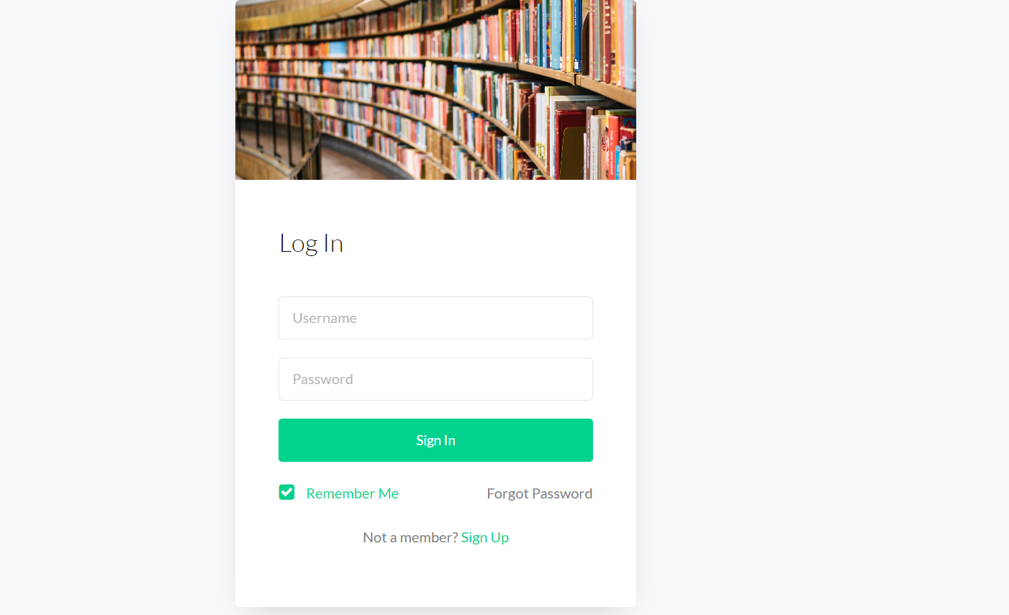

9 Notice of successful order
- Function trigger: after clicking Check out
- Function description: a success message is displayed on the confirm Check out, then user need to click “order history” to find the invoice of products
- Screen layout:
